Lab - System Utilities
- Introduction
In this lab, you will use Windows utilities to configure operating system settings.
- Recommended Equipment
- A computer running Windows

Instructions

Custom Management Console

Explore the management console.
      - To open the Microsoft Management Console, click Start, and search for mmc. Click Yes to allow Microsoft Management Console to make changes to the computer.
      - In the Console1 - [Console Root] window, you can build a custom console. Click File > Add/Remove Snap-in.
      - In the Add or Remove Snap-ins window, you can add a folder snap-in. Scroll down the Available snap-ins: pane to locate the Folder snap-in. Select Folder and click Add>.
      - To add the Link to Web Address snap-in, scroll down the Available snap-ins: pane and select Link to Web Address. Click Add>. In the Link to Web Address wizard window, enter http://www.cisco.com in the Path or URL: field, click Next> to continue.
      - In the Friendly name for the Link to Web Address snap-in box, enter Cisco and click Finish to continue.
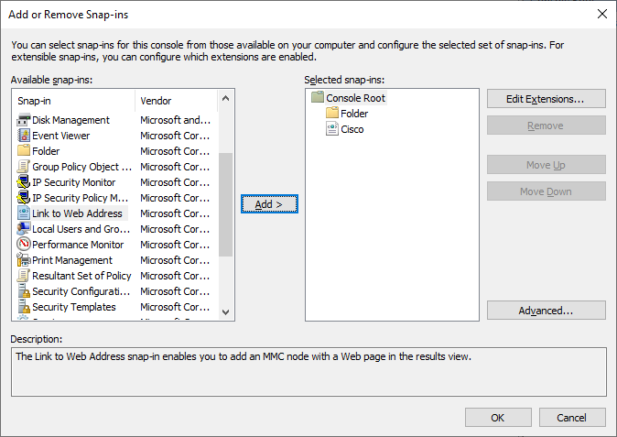
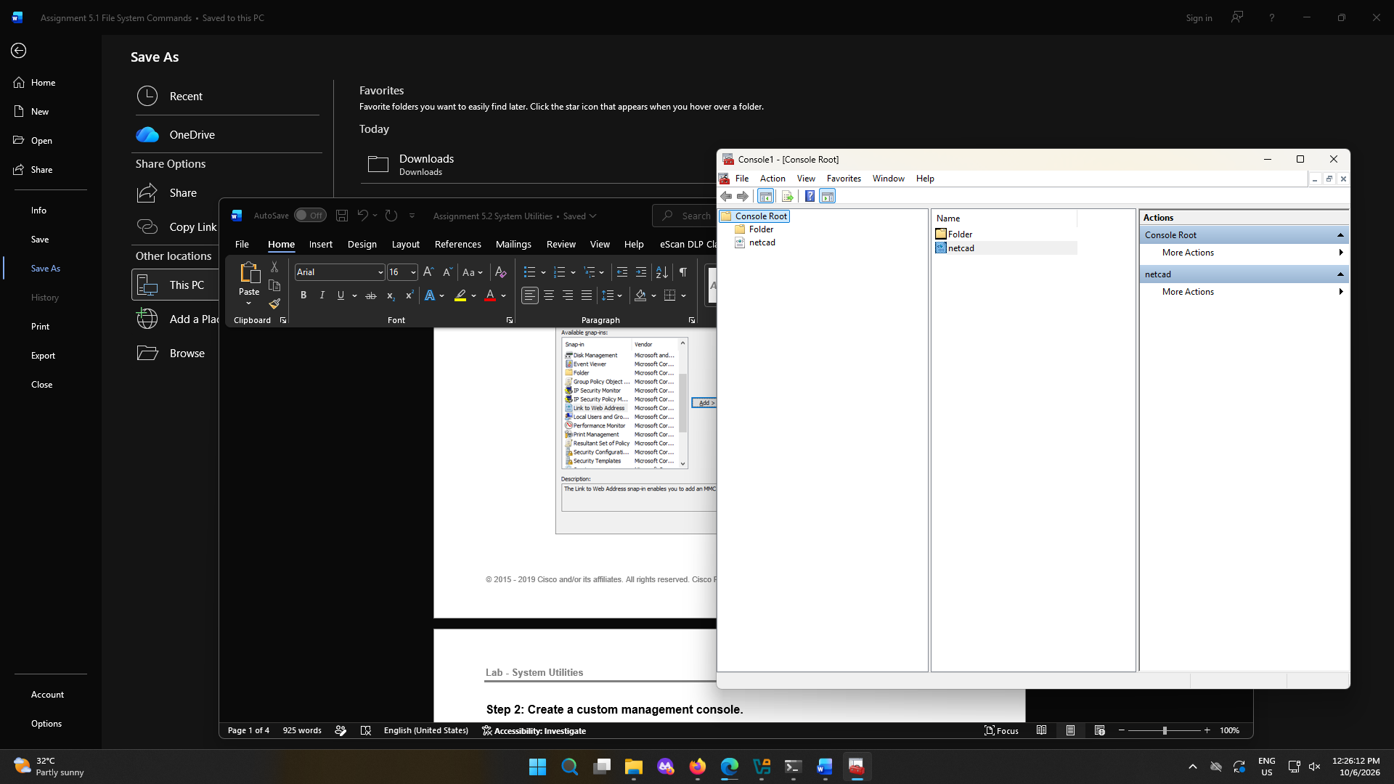

Create a custom management console.
      - To add snap-ins to the folder snap-in, click Advanced.
      - The Advanced window opens. Select Allow changing the parent snap-in. Click OK.
      - A drop-down menu appears for Parent snap-in. In the Parent snap-in box, select Folder.
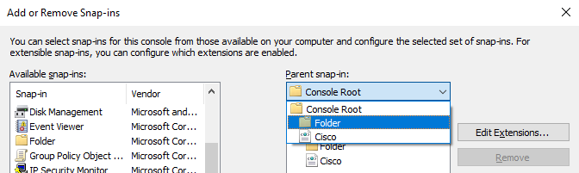
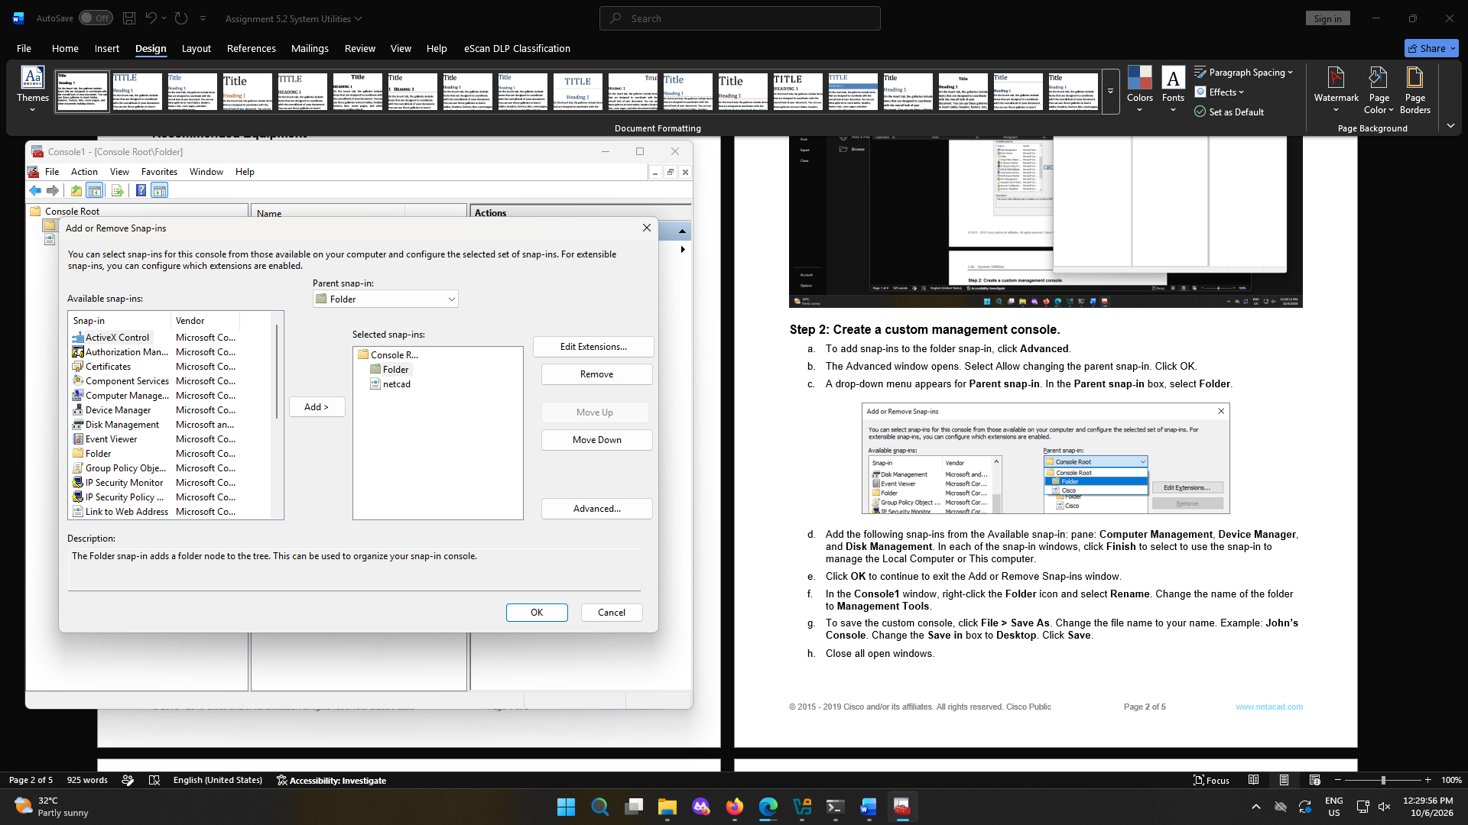
      - Add the following snap-ins from the Available snap-in: pane: Computer Management, Device Manager, and Disk Management. In each of the snap-in windows, click Finish to select to use the snap-in to manage the Local Computer or This computer.
      - Click OK to continue to exit the Add or Remove Snap-ins window.
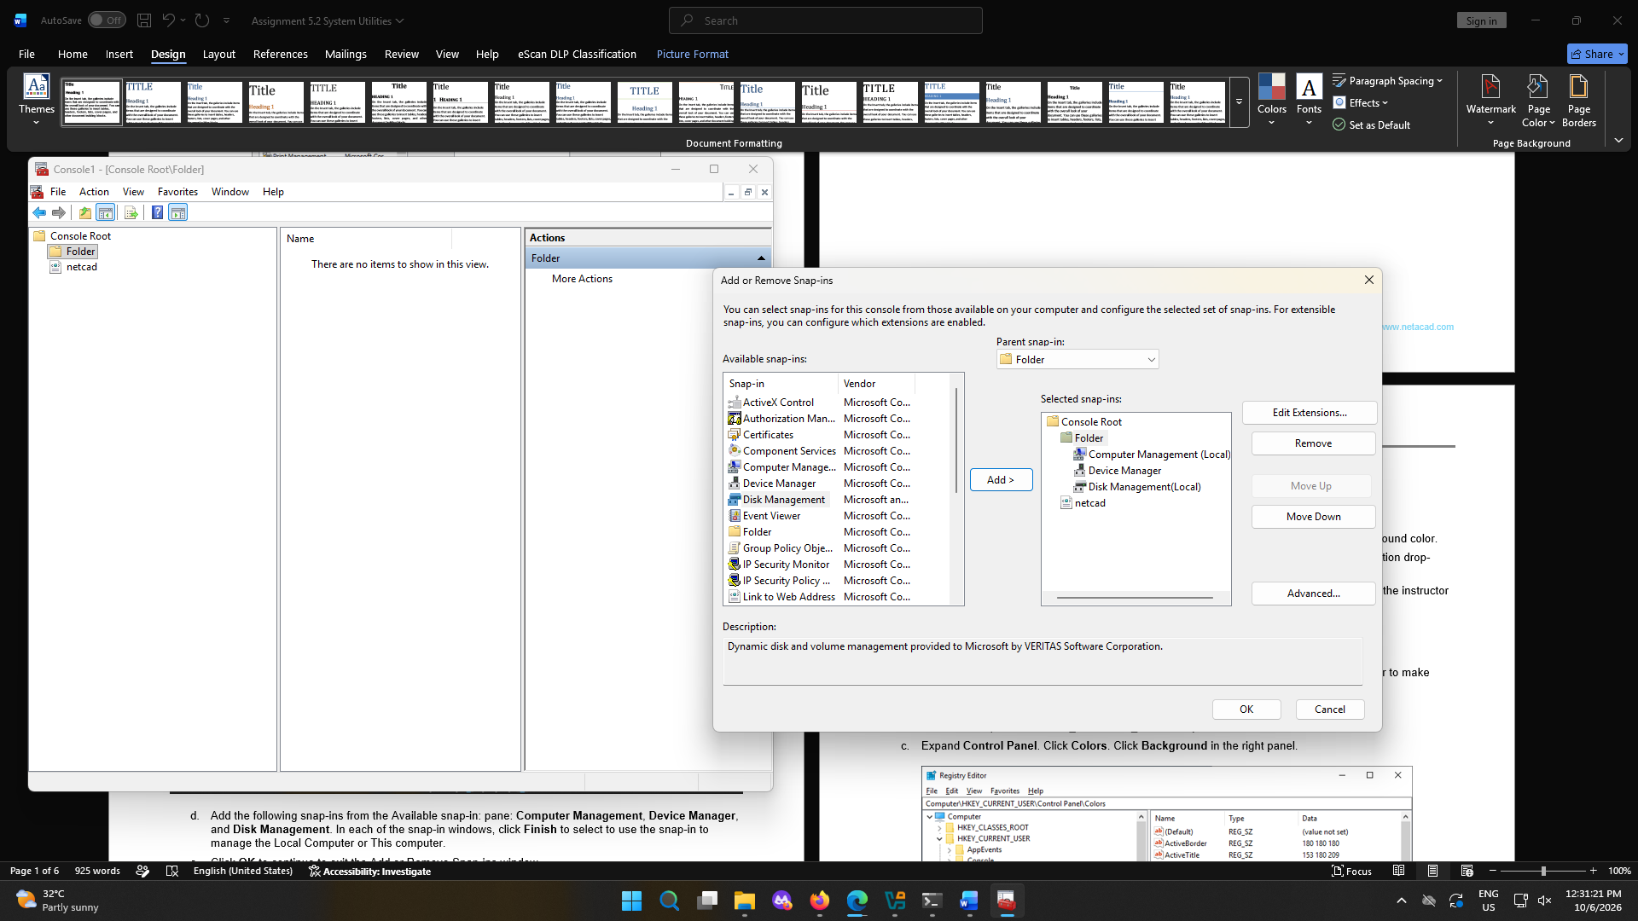
      - In the Console1 window, right-click the Folder icon and select Rename. Change the name of the folder to Management Tools.
      - To save the custom console, click File > Save As. Change the file name to your name. Example: John’s Console. Change the Save in box to Desktop. Click Save.
      - Close all open windows.
      - On the desktop, double-click the Console icon that contains your name to re-open the console with your snap-ins. Click Yes to allow this application to make changes to your device as necessary.
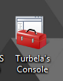
      - Review the Management Tools folder by double-clicking on the tools.
      - Within your custom console, navigate to the Event Viewer.

Question:
What was the path you use to navigate to the Event Viewer?
I clicked the Computer Management (Local’s drop box and then the system tools.
      - Close the Console window when you finish your review. Click No when prompted to save the changes.

Registry Editor

Change your desktop background settings.
      - Right-click the Desktop > select Personalize.

Question:
What is the background picture?

      - In Windows 10, select Solid color in the Background drop-down list. Choose a blue background color.
In Windows 8.1 and 7, click Desktop Background. Select Solid Colors in the Picture Location drop-down list. Choose a blue background color.
      - Click Save changes. The computer screen should now have a blue background. If not, ask the instructor for assistance.
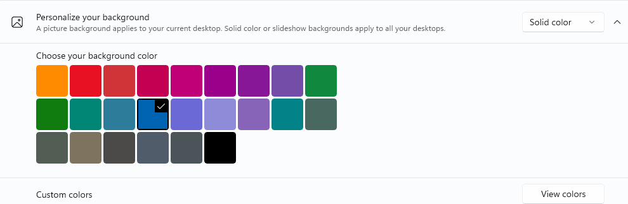
      - Close all open windows.
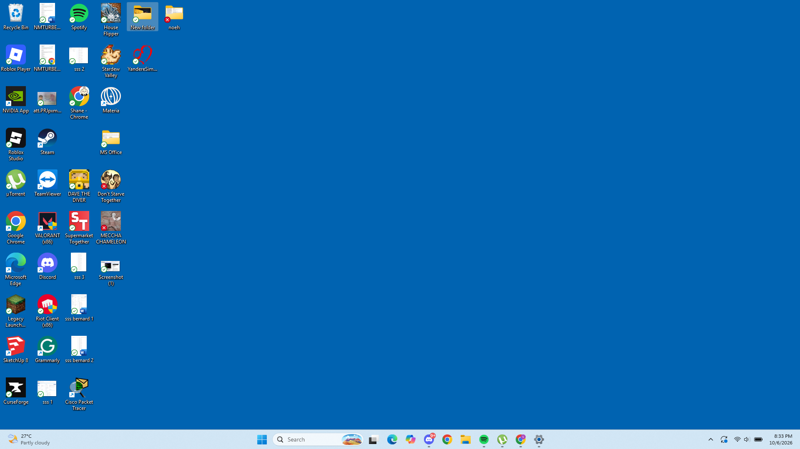

Open the registry editor.
    - To open the Registry Editor, click Start and type regedit. Click Yes to allow Registry Editor to make changes to the computer.
Note: Do not make any changes in the Registry Editor without instructor permission.
    - Select and expand the HKEY_CURRENT_USER entry.
    - Expand Control Panel. Click Colors. Click Background in the right panel.
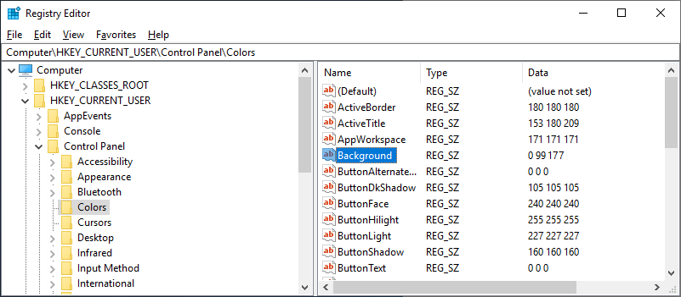
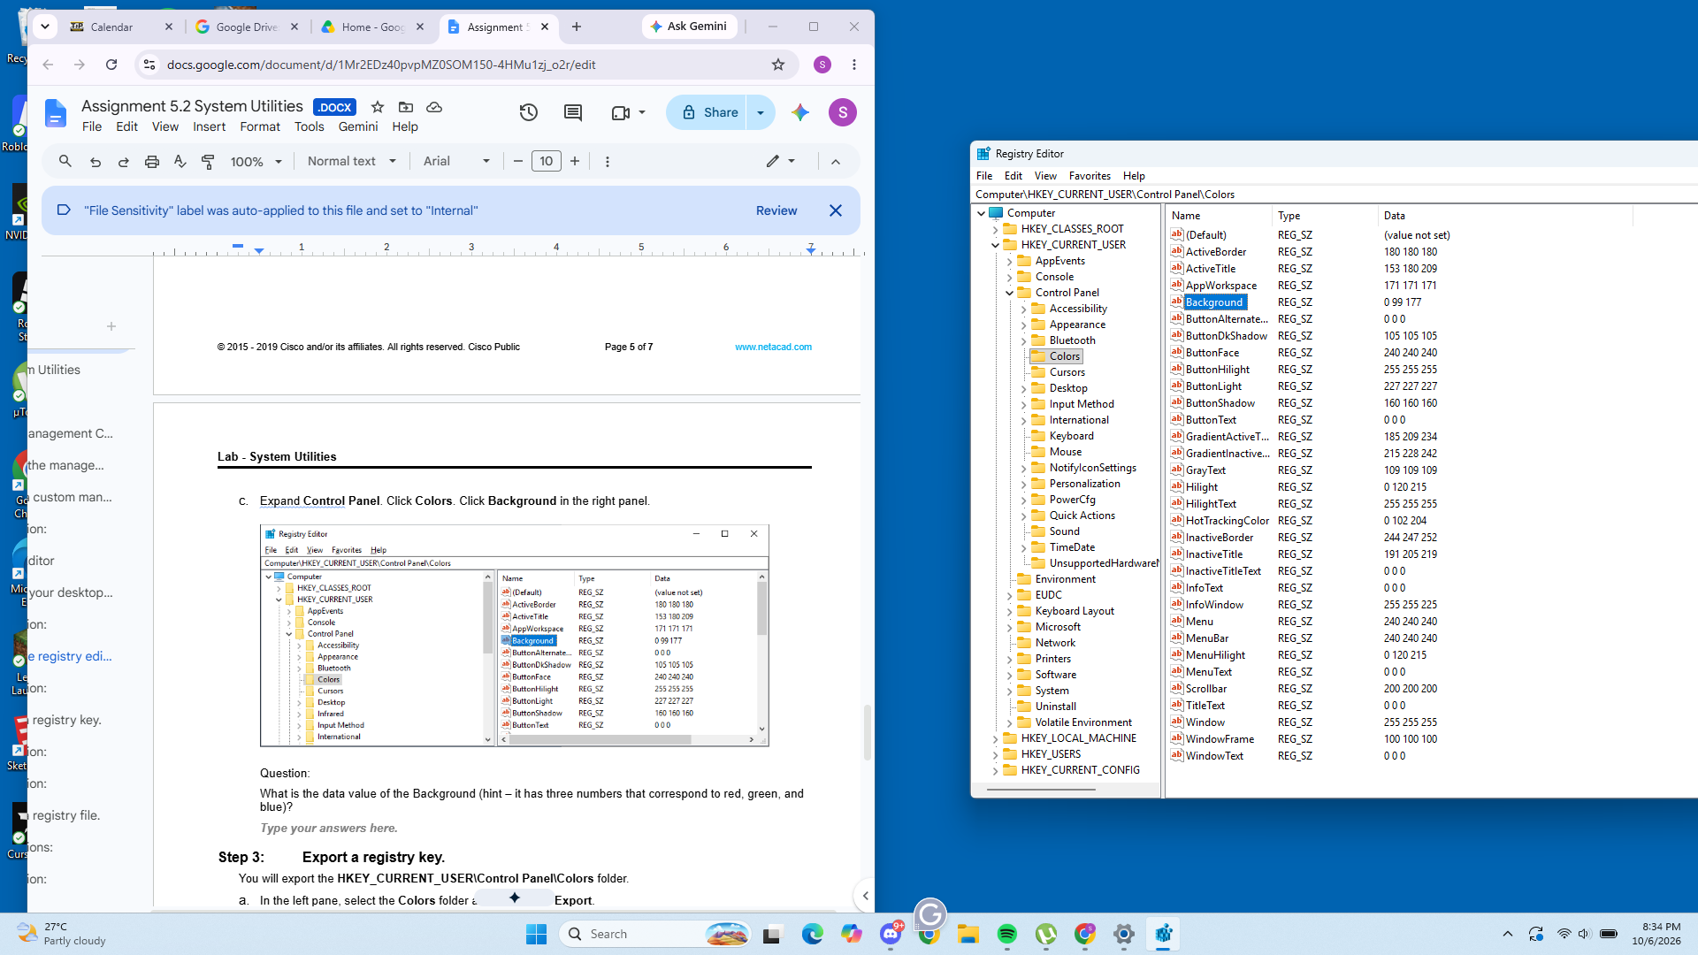

Question:
What is the data value of the Background (hint – it has three numbers that correspond to red, green, and blue)?
An RGB color values of 0 99 177

Export a registry key.
You will export the HKEY_CURRENT_USER\Control Panel\Colors folder.
      - In the left pane, select the Colors folder and click File > Export.
      - Save the file to the Desktop with the name BlueBKG.
      - At the desktop, right-click the BlueBKG.reg icon and select Edit.
      - Notepad opens displaying the contents of BlueBKG.reg.

Question:
What is the data value of the Background?
0 99 177
      - Close the BlueBKG.reg – Notepad window.
      - Open the Personalization window by right-clicking the Desktop > Personalize > Desktop Background. Select a red background color.
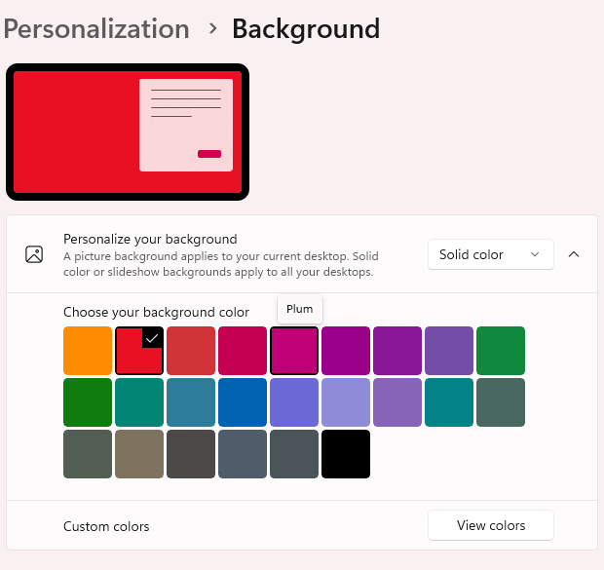
      - Click Save changes. Close the Personalization window.
      - The desktop background should be red. Click the Registry Editor window.
      - On your keyboard, press F5 to refresh the Registry Editor window.

Question:
What is the data value of the Background? Compare the new value in the Registry to the value saved in BlueBKG.reg.
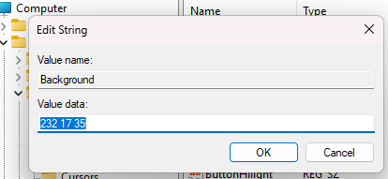
RGB number is higher than the blue due to the color being much more intense

Import a registry file.
You will import the BlueBKG.reg file to change the Desktop ground back to blue.
      - Click the Registry Editor window.
      - Click File > Import. Locate and click the BlueBKG.reg file then click Open.
      - The Registry Editor informational message opens letting you know that keys and values have been successfully added to the registry. Click OK.
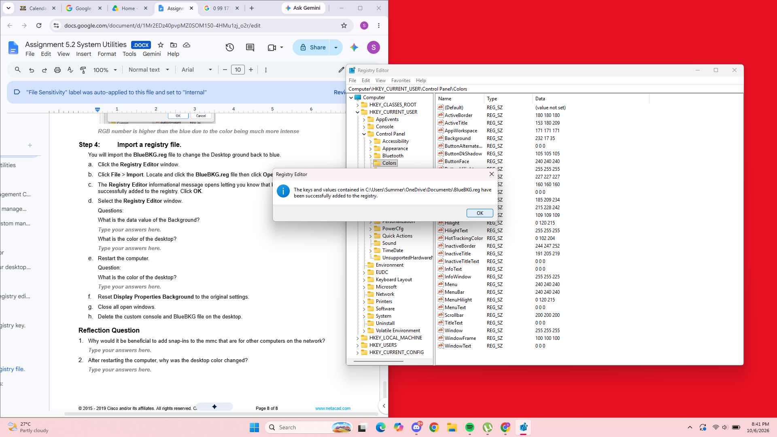
      - Select the Registry Editor window.

Questions:
What is the data value of the Background?
0 99 177 RGB, same value as the blue
What is the color of the desktop?
Red.
      - Restart the computer.

Question:
What is the color of the desktop?
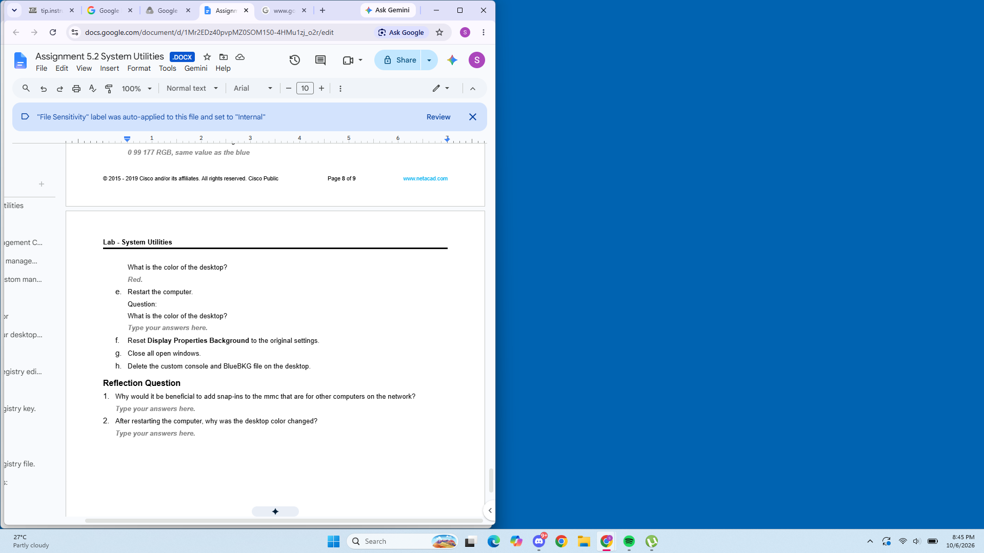
      - Reset Display Properties Background to the original settings.
      - Close all open windows.
      - Delete the custom console and BlueBKG file on the desktop.
- Reflection Question
  - Why would it be beneficial to add snap-ins to the mmc that are for other computers on the network?
Easier to troubleshoot devices/computers that do not have its own keyboard, mouse, etc.
  - After restarting the computer, why was the desktop color changed?
It had processed that the background is supposed to be Blue since we’ve implemented the blue file in the registry editor.
End of Document

